|  |  |  |  |  |
| --- | --- | --- | --- | --- |
| **Grade: 8th grade** | | | **Subject: US History** | |
| **Materials: Notes, Blank maps** | | | **Technology Needed: just projector/smartboard for notes** | |
| **Instructional Strategies:**   * Direct instruction* * Guided practice * Socratic Seminar * Learning Centers * Lecture* * Technology integration* * Other (list) | | * Peer teaching/collaboration/   cooperative learning   * Visuals/Graphic organizers * PBL * Discussion/Debate* * Modeling | **Guided Practices and Concrete Application:** | |
| * Large group activity * Independent activity * Pairing/collaboration* * Simulations/Scenarios * Other (list)  |  | | --- | | Explain: | | * Hands-on * Technology integration * Imitation/Repeat/Mimic |
| **Standard(s)**  **8.2.1, 8.2.4, 8.2.10, 8.1.2** | | | **Differentiation**  **Below Proficiency:**  **Above Proficiency:**  **Approaching/Emerging Proficiency:**  **Modalities/Learning Preferences:** | |
| **Objective(s)**  **Outline what Manifest Destiny is, and introduce the rest of the unit**  **Get students to think about the “Why” behind it**   * **Political, economic, social reasons**   **Bloom’s Taxonomy Cognitive Level:**  **Higher order** | | |
| **Classroom Management- (grouping(s), movement/transitions, etc.)**  **Few pair and shares throughout the lecture** | | | **Behavior Expectations- (systems, strategies, procedures specific to the lesson, rules and expectations, etc.)** | |
| **Minutes** | **Procedures** | | | |
| **0** | **Set-up/Prep:**  **Just print out blank maps and prepare slides** | | | |
| **5-10** | **Engage: (opening activity/ anticipatory Set – access prior learning / stimulate interest /generate questions, etc.)**  **Current events activity. Get the students to think about the world around them so we can link the topic of discussion to today.**  **Have students come in with a current event that they will discuss and share with a small group, then we will bring it back to the full class.** | | | |
| **15-20** | **Explain: (concepts, procedures, vocabulary, etc.)**  **Manifest Destiny will be the focal point to the unit and this day will be an introduction to that topic. We will define it, and talk about the reasons for it, putting an emphasis on the “Why”, we will take a look at political, economic, and social reasons why.** | | | |
| **10-15** | **Explore: (independent, concreate practice/application with relevant learning task -connections from content to real-life experiences,** **reflective questions- probing or clarifying questions)**  **Introduce maps that the students will be using for the rest of the Unit. Students will begin with a blank map and use today to color in the parts that we have already covered. As we move west in the lecture and cover new things geographically, the students will be asked to add these things to their maps and color them. (Directions and sample included)** | | | |
| **Remainder of class** | **Review (wrap up and transition to next activity):**  **Quick period for any questions moving forward** | | | |
| **Formative Assessment: (linked to objectives)**  **Progress monitoring throughout lesson- clarifying questions, check-**  **in strategies, etc.**  **Constant check for understanding throughout lecture, calling on students to give input during lecture**    **Consideration for Back-up Plan:**  **Not much could go wrong with this lesson, but if we need to cut the lecture short to get to the maps I will.** | | | **Summative Assessment (linked back to objectives)**  **End of lesson:**  **Exit slip with one new thing they learned about Manifest Destiny**  **If applicable- overall unit, chapter, concept, etc.:** | |

|  |  |  |  |  |  |  |
| --- | --- | --- | --- | --- | --- | --- |
| **Grade: 8th** | | | | | **Subject: US History** | |
| **Materials: Computer or iPad for research help** | | | | | **Technology Needed: Same as materials** | |
| **Instructional Strategies:**   * Direct instruction* * Guided practice * Socratic Seminar * Learning Centers * Lecture * * Technology integration* * Other (list) | | | * Peer teaching/collaboration/   cooperative learning*   * Visuals/Graphic organizers* * PBL * Discussion/Debate* * Modeling | | **Guided Practices and Concrete Application:** | |
| * Large group activity* * Independent activity* * Pairing/collaboration* * Simulations/Scenarios* * Other (list)  |  | | --- | | Explain: | | * Hands-on* * Technology integration* * Imitation/Repeat/Mimic |
| **Standard(s) 8.1.2, 8.2.1, 8.2.4, 8.2.10** | | | | | **Differentiation**  **Below Proficiency:**  **Above Proficiency:**  **Approaching/Emerging Proficiency:**  **Modalities/Learning Preferences:** | |
| **Objective(s)**  **Students will use primary sources to explore the findings of the Lewis and Clark expedition.**  **Students will also be able to link the discoveries with their everyday lives and explain why this expedition is so important to the world today.**  **Bloom’s Taxonomy Cognitive Level:**  **Use of higher order thinking skills** | | | | |
| **Classroom Management- (grouping(s), movement/transitions, etc.)**  **I will be grouping mostly with proximity in this lesson.** | | | | | **Behavior Expectations- (systems, strategies, procedures specific to the lesson, rules and expectations, etc.)** | |
| **Minutes** | **Procedures** | | | | | |
| **1 at beginning** | **Set-up/Prep: Just pull up prezi presentation and Journal website** | | | | | |
| **3-5 min** | **Engage: (opening activity/ anticipatory Set – access prior learning / stimulate interest /generate questions, etc.)**  **Have students go up to the board and have them write one word that best describes the Lewis and Clark Expedition** | | | | | |
| **15-20 min** | **Explain: (concepts, procedures, vocabulary, etc.)**  **Go through prezi presentation**  **Explain how Journal site works**  **https://lewisandclarkjournals.unl.edu/** | | | | | |
| **Time between lecture and reflection** | **Explore: (independent, concreate practice/application with relevant learning task -connections from content to real-life experiences,** **reflective questions- probing or clarifying questions)**  **Student will explore the Journal site with a partner while filling out an ACAPS worksheet as they explore** | | | | | |
| **Last 5 min** | **Review (wrap up and transition to next activity):**  **Students will pair and share with another group near them explaining cool things that they found. I will also ask 1-2 students to share something with the whole class that they found. If time, introduce final L & C project.** | | | | | |
| **Formative Assessment: (linked to objectives)**  **Progress monitoring throughout lesson- clarifying questions, check-**  **in strategies, etc.**  **I will constantly be checking for understanding during the lecture portion, I will be cold calling and asking some open-ended questions throughout.**    **Consideration for Back-up Plan:**  **I will have a few copies of journals printed out if there is a technical difficulty so the student can still participate** | | | | | **Summative Assessment (linked back to objectives)**  **End of lesson: ACAPS WS**  **If applicable- overall unit, chapter, concept, etc.:** | |
| **Grade: 8th** | | | | | **Subject: US History** | |
| **Materials: Notes** | | | | | **Technology Needed:** | |
| **Instructional Strategies:**   * Direct instruction* * Guided practice * Socratic Seminar * Learning Centers * Lecture* * Technology integration * Other (list) | | | | * Peer teaching/collaboration/   cooperative learning*   * Visuals/Graphic organizers* * PBL * Discussion/Debate * Modeling | **Guided Practices and Concrete Application:** | |
| * Large group activity * Independent activity * Pairing/collaboration* * Simulations/Scenarios * Other (list)  |  | | --- | | Explain: | | * Hands-on * Technology integration * Imitation/Repeat/Mimic |
| **Standard(s)**  **8.1.2, 8.2.1, 8.2.4, 8.2.10,** | | | | | **Differentiation**  **Below Proficiency:**  **Above Proficiency:**  **Approaching/Emerging Proficiency:**  **Modalities/Learning Preferences:** | |
| **Objective(s)**  **Cover the “other explorers” including, Pike, Fremont, and Bridger, look at what they discovered and where they explored. Be able to compare and contrast what they did and where they explored.**  **Bloom’s Taxonomy Cognitive Level:** | | | | |
| **Classroom Management- (grouping(s), movement/transitions, etc.)**  **Students will work individually on compare and contrast tool then share with those around them** | | | | | **Behavior Expectations- (systems, strategies, procedures specific to the lesson, rules and expectations, etc.)** | |
| **Minutes** | | **Procedures** | | | | |
| **0** | | **Set-up/Prep: Get notes pulled up** | | | | |
| **5-10** | | **Engage: (opening activity/ anticipatory Set – access prior learning / stimulate interest /generate questions, etc.)**  **Sticky note activity: Students place a sticky note on the board with their answer to the question, “Was the expansion of the United States a Good or Bad thing? Why?” There will be an area for “Good” and “Bad” arguments. And we will discuss briefly.** | | | | |
| **10-15** | | **Explain: (concepts, procedures, vocabulary, etc.)**  **We will then cover a few more people who explored the west and compare what we find out about them to what Lewis and Clark did. These explorers include, Zebulon Pike, Jim Bridger, and John C. Fremont.** | | | | |
| **15-20** | | **Explore: (independent, concreate practice/application with relevant learning task -connections from content to real-life experiences,** **reflective questions- probing or clarifying questions)**  **Students will compare and contrast the 4 explorers we have learned about using a graphic organizer that is included. What isn’t finished in class will be taken home to complete** | | | | |
| **Beginning of class** | | **Review (wrap up and transition to next activity):**  **Introduce end of Unit Lewis and Clark Project. Directions and Rubric attached. (if there was not enough time yesterday)** | | | | |
| **Formative Assessment: (linked to objectives)**  **Progress monitoring throughout lesson- clarifying questions, check-**  **in strategies, etc.**  **Checking for understanding during lesson, cold calling, asking for feedback, open ended questions, etc.**    **Consideration for Back-up Plan:** | | | | | **Summative Assessment (linked back to objectives)**  **End of lesson:**  **Compare and contrast Graphic Organizer**  **If applicable- overall unit, chapter, concept, etc.:** | |
| **Reflection (What went well? What did the students learn? How do you know? What changes would you make?):** | | | | | | |

|  |  |  |  |  |
| --- | --- | --- | --- | --- |
| **Grade: 8th** | | | **Subject: US History** | |
| **Materials: Textbook, RAFT outlines** | | | **Technology Needed: None** | |
| **Instructional Strategies:**   * Direct instruction * Guided practice* * Socratic Seminar * Learning Centers * Lecture * Technology integration * Other (list) | | * Peer teaching/collaboration/   cooperative learning*   * Visuals/Graphic organizers * PBL * Discussion/Debate * Modeling* | **Guided Practices and Concrete Application:** | |
| * Large group activity* * Independent activity* * Pairing/collaboration* * Simulations/Scenarios* * Other (list)  |  | | --- | | Explain: | | * Hands-on * Technology integration * Imitation/Repeat/Mimic |
| **Standard(s)**  **8.1.2, 8.2.1, 8.2.4, 8.2.10,** | | | **Differentiation**  **Below Proficiency:**  **Above Proficiency:**  **Approaching/Emerging Proficiency:**  **Modalities/Learning Preferences:** | |
| **Objective(s)**  **Students will attempt to put themselves in the shoes of someone who was involved in westward expansion. They will read the chapter in the text and then so a RAFT activity.**  **Bloom’s Taxonomy Cognitive Level: Creativity, High** | | |
| **Classroom Management- (grouping(s), movement/transitions, etc.)**  **Grouping based on proximity** | | | **Behavior Expectations- (systems, strategies, procedures specific to the lesson, rules and expectations, etc.)** | |
| **Minutes** | **Procedures** | | | |
| **0** | **Set-up/Prep:** | | | |
| **5** | **Engage: (opening activity/ anticipatory Set – access prior learning / stimulate interest /generate questions, etc.)**  **Have students write down three types of people who had something to do with Westward expansion. Could be as important as the president or simply someone who traveled on one of the trails. Share in a small proximal group what they wrote.** | | | |
| **15-20** | **Explain: (concepts, procedures, vocabulary, etc.)**  **Students will read on their own the next chapter in the text. I think it is good to have the students find some of the information on their own. To Check for understanding I will have them Answer a few of the critical thinking question at the end of the chapter.** | | | |
| **Rest of the Class** | **Explore: (independent, concreate practice/application with relevant learning task -connections from content to real-life experiences,** **reflective questions- probing or clarifying questions)**  **The rest of the class will be used to perform a RAFT writing activity. Here they choose a Role, an Audience, a Format, and a Topic. Then they write a paragraph using that outline from the perspective of someone who was involved in the move west. We will then share with a small group and have a few volunteers read what they wrote for the class.** | | | |
| **3** | **Review (wrap up and transition to next activity):**  **End of class discussion about the RAFT activity. What did they think about when they were writing from a different perspective than their own** | | | |
| **Formative Assessment: (linked to objectives)**  **Progress monitoring throughout lesson- clarifying questions, check- in strategies, etc.**  **I will be monitoring as they are reading. Asking questions individually to check for understanding.**    **Consideration for Back-up Plan:**  **If reading takes longer than expected I will have the students pair up to do the questions so we can get them answered quickly and move onto the RAFT** | | | **Summative Assessment (linked back to objectives)**  **End of lesson: Understanding questions in chapter, and deep thinking in the RAFT activity**  **If applicable- overall unit, chapter, concept, etc.:** | |
| **Reflection (What went well? What did the students learn? How do you know? What changes would you make?):** | | | | |

|  |  |  |  |  |
| --- | --- | --- | --- | --- |
| **Grade: 8th** | | | **Subject: US History** | |
| **Materials: Coloring tools, blank maps** | | | **Technology Needed: None** | |
| **Instructional Strategies:**   * Direct instruction* * Guided practice * Socratic Seminar * Learning Centers * Lecture* * Technology integration * Other (list) | | * Peer teaching/collaboration/   cooperative learning   * Visuals/Graphic organizers* * PBL * Discussion/Debate* * Modeling* | **Guided Practices and Concrete Application:** | |
| * Large group activity * Independent activity* * Pairing/collaboration * Simulations/Scenarios * Other (list)  |  | | --- | | Explain: | | * Hands-on* * Technology integration * Imitation/Repeat/Mimic |
| **Standard(s)**  **8.1.2, 8.2.1, 8.2.4, 8.5.2, 8.6.1, 8.2.10** | | | **Differentiation**  **Below Proficiency:**  **Above Proficiency:**  **Approaching/Emerging Proficiency:**  **Modalities/Learning Preferences:** | |
| **Objective(s)**  **Students will understand the differences between the sectionalized parts of the United States. They will be able to use what they know to design a map with illustrations showing the different sections of the US and the characteristics of them.**  **Bloom’s Taxonomy Cognitive Level: Creation** | | |
| **Classroom Management- (grouping(s), movement/transitions, etc.)** | | | **Behavior Expectations- (systems, strategies, procedures specific to the lesson, rules and expectations, etc.)** | |
| **Minutes** | **Procedures** | | | |
| **0** | **Set-up/Prep: Have blank maps and coloring tools ready** | | | |
| **5** | **Engage: (opening activity/ anticipatory Set – access prior learning / stimulate interest /generate questions, etc.)**  **Quick recap of what we have been talking about. Transition into the day’s activities.** | | | |
| **15-20** | **Explain: (concepts, procedures, vocabulary, etc.)**  **Set of notes on Nationalism that emerged after the war of 1812 and the sectionalism that formed because of the differences in economic systems and states’ rights. I will go into detail about the differences in these different regions in the US.** | | | |
| **20** | **Explore: (independent, concreate practice/application with relevant learning task -connections from content to real-life experiences,** **reflective questions- probing or clarifying questions)**  **We will then go into an activity that I will have the students take a blank map and break it into 3 different sections (north south and west) in those sections they will label it and add three different illustrations that describe the region. It can be any of the things that we discussed or something else that shows a key characteristic. Then I will have the students bring a written description of what they drew to class the next day explaining why they drew what they did in each section.** | | | |
| **Remainder** | **Review (wrap up and transition to next activity):**  **Time for closing and brief wrap-up if the students have questions about their project or anything else in the class.** | | | |
| **Formative Assessment: (linked to objectives)**  **Progress monitoring throughout lesson- clarifying questions, check-**  **in strategies, etc.**  **open-ended questions, and cold calling to check for understanding during lecture**    **Consideration for Back-up Plan:** | | | **Summative Assessment (linked back to objectives)**  **End of lesson: Map project should inform me if they are understanding the information**  **If applicable- overall unit, chapter, concept, etc.:** | |
| **Reflection (What went well? What did the students learn? How do you know? What changes would you make?):** | | | | |

|  |  |  |  |  |
| --- | --- | --- | --- | --- |
| **Grade: 8th** | | | **Subject: US History** | |
| **Materials: internet access** | | | **Technology Needed:** | |
| **Instructional Strategies:**   * Direct instruction* * Guided practice * Socratic Seminar * Learning Centers * Lecture* * Technology integration* * Other (list) | | * Peer teaching/collaboration/   cooperative learning   * Visuals/Graphic organizers * PBL * Discussion/Debate * Modeling | **Guided Practices and Concrete Application:** | |
| * Large group activity* * Independent activity * Pairing/collaboration * Simulations/Scenarios * Other (list)  |  | | --- | | Explain: | | * Hands-on * Technology integration* * Imitation/Repeat/Mimic |
| **Standard(s)**  **8.1.2, 8.2.1, 8.2.4, 8.2.10,** | | | **Differentiation**  **Below Proficiency:**  **Above Proficiency:**  **Approaching/Emerging Proficiency:**  **Modalities/Learning Preferences:** | |
| **Objective(s)**  **This will be a quick learning day where we will cover a lot of information about the Mexican-American war and the land in which we obtained from that.**  **Bloom’s Taxonomy Cognitive Level:**  **Higher order because of the questioning** | | |
| **Classroom Management- (grouping(s), movement/transitions, etc.)**  **I will be moving around the room and stopping the video when there is an important point that I want to discuss.** | | | **Behavior Expectations- (systems, strategies, procedures specific to the lesson, rules and expectations, etc.)** | |
| **Minutes** | **Procedures** | | | |
|  | **Set-up/Prep: Find video and prepare it. Provide note taking guide w/ Higher order thinking questions on it that go beyond the film** | | | |
| **5-10** | **Engage: (opening activity/ anticipatory Set – access prior learning / stimulate interest /generate questions, etc.)**  **I will begin with some prompting questions to get them thinking about the impact of this war and what it meant for the overall theme of the unit which is Manifest Destiny.** | | | |
| **25-30** | **Explain: (concepts, procedures, vocabulary, etc.)**  **I will be showing a video from the History Channel on the Mexican American war. I will not show the whole thing, because I will be stopping it to have discussions throughout. I will have a note taking guide with some open-ended questions as well as some check for understanding stuff as well. This way we can get the information quickly with the video, while still thinking critically about what the information means to our over-arching question.** | | | |
| **During video** | **Explore: (independent, concreate practice/application with relevant learning task -connections from content to real-life experiences,** **reflective questions- probing or clarifying questions)**  **Use of note taking guide and discussion throughout the video will help them retain the information moving forward in the unit** | | | |
| **5** | **Review (wrap up and transition to next activity):**  **Thoughts and things that they learned from the movie on an Exit slip before they leave** | | | |
| **Formative Assessment: (linked to objectives)**  **Progress monitoring throughout lesson- clarifying questions, check-in strategies, etc.**  **I will be stopping the video to check for understanding and asking questions about the information they should be picking up on**  **Consideration for Back-up Plan:**  **I will have a reading assignment as a back-up that will cover the same information as the video in case of a technological error** | | | **Summative Assessment (linked back to objectives)**  **End of lesson:**  **I will collect the note taking guide and use the discussion as a check for understanding.**  **If applicable- overall unit, chapter, concept, etc.:** | |
| **Reflection (What went well? What did the students learn? How do you know? What changes would you make?):** | | | | |

|  |  |  |  |  |
| --- | --- | --- | --- | --- |
| **Grade: 8th** | | | **Subject: US History** | |
| **Materials: Maps and markers** | | | **Technology Needed: none** | |
| **Instructional Strategies:**   * Direct instruction* * Guided practice * Socratic Seminar * Learning Centers * Lecture* * Technology integration* * Other (list) | | * Peer teaching/collaboration/   cooperative learning*   * Visuals/Graphic organizers* * PBL * Discussion/Debate* * Modeling* | **Guided Practices and Concrete Application:** | |
| * Large group activity* * Independent activity* * Pairing/collaboration* * Simulations/Scenarios* * Other (list)  |  | | --- | | Explain: | | * Hands-on* * Technology integration* * Imitation/Repeat/Mimic |
| **Standard(s)**  **8.1.2, 8.2.1, 8.2.4, 8.2.10,** | | | **Differentiation**  **Below Proficiency:**  **Above Proficiency:**  **Approaching/Emerging Proficiency:**  **Modalities/Learning Preferences:** | |
| **Objective(s) Students will learn about and understand what the trails leading west were all about. Where they start and end, who was on them, why did they go, what were some struggles they had?**  **Bloom’s Taxonomy Cognitive Level: High** | | |
| **Classroom Management- (grouping(s), movement/transitions, etc.)**  **Students may pick their group for this activity. It will be a fun couple of days and more enjoyment = more learning in this activity.** | | | **Behavior Expectations- (systems, strategies, procedures specific to the lesson, rules and expectations, etc.)**  **Students will be respectful but also able to have a lot of fun.** | |
| **Minutes 2 Day lesson** | **Procedures** | | | |
|  | **Set-up/Prep: Get computers set up and pull up Oregon Trail game. Make sure it is working on all of them.** | | | |
| **5** | **Engage: (opening activity/ anticipatory Set – access prior learning / stimulate interest /generate questions, etc.)**  **Ask students to make a quick list of 3 different people who they think would use the trails going west. (3 sticky notes for later)** | | | |
| **35-40** | **Explain: (concepts, procedures, vocabulary, etc.)**  **Go over notes on the trails- where they led to and what was there. Includes California, Utah, Oregon etc… This is longer than I would usually spend on notes, but I think it is better to get them all done the first day then let them explore once they have all of the information that they need. I will break up the lecture with mini discussions and videos and also a sticky note activity to get them up and moving and help me break up the lecture.** | | | |
| **40-45** | **Explore: (independent, concreate practice/application with relevant learning task -connections from content to real-life experiences,** **reflective questions- probing or clarifying questions)**  **Students will play the computer game, Oregon Trail. Throughout this, I will have the students keep a “journal” where they will be required to log all of the decisions that they made throughout the game. The game ends in two different ways, either they make it to their final destination, or everybody dies on the way. In either case I want the students to write about their journey. I want them to tell me what went wrong, what went right, what they could have done differently, why they made the decisions that they did, and what they learned from the activity. They will play in groups of 4 but they will all complete their own writing activity.** | | | |
| **Remainder** | **Review (wrap up and transition to next activity):**  **After the students are done writing we will have a discussion where the students can share good and bad stories from their “Journey West”. I will also ask them why they think I had them play the game, I want them to understand that life was hard on the trails and that all different types of people went west because of the opportunities that were there.**   * **Hand out Study guide** | | | |
| **Formative Assessment: (linked to objectives)**  **Progress monitoring throughout lesson- clarifying questions, check-in strategies, etc. I will be asking questions throughout the lecture to check for understanding. I will also go around and ask higher order questions to the students while they are playing the game so that they are thinking deeply about the things happening in the game and the decisions that they are making.**  **Consideration for Back-up Plan:**  **If something crazy happens with the technology, I have a back-up plan where the students “Load their own wagon” and write a short story or journal in a group about what could happen on their trip.** | | | **Summative Assessment (linked back to objectives)**  **End of lesson:**  **I will collect the writing activity from all of the students to ensure that they understood the point of the activity.**  **If applicable- overall unit, chapter, concept, etc.:** | |
| **Reflection (What went well? What did the students learn? How do you know? What changes would you make?):** | | | | |

|  |  |  |  |  |
| --- | --- | --- | --- | --- |
| **Grade: 8th** | | | **Subject: US History** | |
| **Materials: Study guides, Jeopardy Game** | | | **Technology Needed: Jeopardy Game** | |
| **Instructional Strategies:**   * Direct instruction * Guided practice* * Socratic Seminar * Learning Centers * Lecture * Technology integration* * Other (list) | | * Peer teaching/collaboration/   cooperative learning*   * Visuals/Graphic organizers * PBL * Discussion/Debate * Modeling | **Guided Practices and Concrete Application:** | |
| * Large group activity* * Independent activity * Pairing/collaboration * Simulations/Scenarios * Other (list)  |  | | --- | | Explain: | | * Hands-on * Technology integration* * Imitation/Repeat/Mimic |
| **Standard(s)**  **8.1.2, 8.2.1, 8.2.4, 8.5.2, 8.6.1, 8.2.10** | | | **Differentiation**  **Below Proficiency:**  **Above Proficiency:**  **Approaching/Emerging Proficiency:**  **Modalities/Learning Preferences:** | |
| **Objective(s)**  **Students will have a chance to review for the final test and ask questions about the topics from their study guide. I will give them a chance to play a jeopardy game that I created or work independently on their study guide**  **Bloom’s Taxonomy Cognitive Level:** | | |
| **Classroom Management- (grouping(s), movement/transitions, etc.)**  **I will create teams by numbering the students 1-4** | | | **Behavior Expectations- (systems, strategies, procedures specific to the lesson, rules and expectations, etc.)**  **Students will be respectful and if they can’t do that we will all just work silently on our study guides** | |
| **Minutes** | **Procedures** | | | |
|  | **Set-up/Prep:**  **Draw “Jeopardy” on the board split into teams** | | | |
| **5** | **Engage: (opening activity/ anticipatory Set – access prior learning / stimulate interest /generate questions, etc.)**  **Ask the students if they came across any difficult questions as they were filling out their study guides.** | | | |
| **40** | **Explain: (concepts, procedures, vocabulary, etc.)**  **Play the review game of Jeopardy, Game will include all different types of questions including some higher order thinking questions for more points** | | | |
| **-** | **Explore: (independent, concreate practice/application with relevant learning task -connections from content to real-life experiences,** **reflective questions- probing or clarifying questions)**  **More of the review game** | | | |
| **5** | **Review (wrap up and transition to next activity):**  **Last chance for questions before the test tomorrow** | | | |
| **Formative Assessment: (linked to objectives)**  **Progress monitoring throughout lesson- clarifying questions, check-in strategies, etc.**  **Always checking for understanding with the review game**    **Consideration for Back-up Plan:**  **If students get out of hand they will work on their study guides independently and I will answer questions that they have.** | | | **Summative Assessment (linked back to objectives)**  **End of lesson:**  **Test**  **If applicable- overall unit, chapter, concept, etc.:**  **This will be the summative assessment day.** | |
| **Reflection (What went well? What did the students learn? How do you know? What changes would you make?):** | | | | |

|  |  |  |  |  |
| --- | --- | --- | --- | --- |
| **Grade: 8th** | | | **Subject: US History** | |
| **Materials: Tests, extra pencils** | | | **Technology Needed: none** | |
| **Instructional Strategies:**   * Direct instruction * Guided practice * Socratic Seminar * Learning Centers * Lecture * Technology integration * Other (list) | | * Peer teaching/collaboration/   cooperative learning   * Visuals/Graphic organizers * PBL * Discussion/Debate * Modeling | **Guided Practices and Concrete Application:** | |
| * Large group activity * Independent activity* * Pairing/collaboration * Simulations/Scenarios * Other (list)  |  | | --- | | Explain: | | * Hands-on * Technology integration * Imitation/Repeat/Mimic |
| **Standard(s)**  **8.1.2, 8.2.1, 8.2.4, 8.5.2, 8.6.1, 8.2.10** | | | **Differentiation**  **Below Proficiency:**  **Above Proficiency:**  **Approaching/Emerging Proficiency:**  **Modalities/Learning Preferences:** | |
| **Objective(s)**  **Students will complete the summative assessment for the Unit.**  **Bloom’s Taxonomy Cognitive Level:**  **Higher order thinking questions on the test** | | |
| **Classroom Management- (grouping(s), movement/transitions, etc.)**  **I will move around the class to make sure there is no cheating or working together on the test.** | | | **Behavior Expectations- (systems, strategies, procedures specific to the lesson, rules and expectations, etc.)** | |
| **Minutes** | **Procedures** | | | |
|  | **Set-up/Prep:**  **Hand out tests** | | | |
| **5** | **Engage: (opening activity/ anticipatory Set – access prior learning / stimulate interest /generate questions, etc.)**  **Last chance for questions and concepts before I hand out the tests** | | | |
| **45** | **Explain: (concepts, procedures, vocabulary, etc.)**  **Test** | | | |
|  | **Explore: (independent, concreate practice/application with relevant learning task -connections from content to real-life experiences,** **reflective questions- probing or clarifying questions)**  **Test** | | | |
|  | **Review (wrap up and transition to next activity):** | | | |
| **Formative Assessment: (linked to objectives)**  **Progress monitoring throughout lesson- clarifying questions, check- in strategies, etc.**  **I will be available for questions individually at my desk if they need help with some clarification**  **Consideration for Back-up Plan:** | | | **Summative Assessment (linked back to objectives)**  **End of lesson:**  **If applicable- overall unit, chapter, concept, etc.:** | |
| **There will be an extra day and a half set aside for presentations of their L&C Projects after the test. I have the directions and rubric I will be using attached.** | | | | |

**Examples and directions and rubrics for the unit:**

NAME:______________

DATE:______________

Westward Expansion Map Directions

1. Draw and label the following on your map. Use the Textbook and the maps provided to help you locate these things. DO NOT USE MARKERS FOR THE TERRITORIES! You will use them for the mountains, rivers, and trails. Use abbreviations for all of the states.

* **The Appalachian Mountains**
* **The Rocky Mountains**
* **13 Original states (Color these GREEN) Label the states in BLACK pen**
* **Treaty of Paris, 1783 (Color these GREY, before you color it all be sure to look at the directions for the Northwest Territory because they do intersect) Label the states included with BLACK pen**
* **The Ohio River**
* **Mississippi River**
* **Northwest Territory, 1787 (There is an overlap here. Add YELLOW lines to the states included in this territory)**
* **Missouri River**
* **The Louisiana Territory, 1803 (Color this region ORANGE) Label the states included**
* **Great Britain Area, 1818 (Color it DARK BLUE)**
* **Florida, 1819 (Color it PINK)**
* **Annexation of Texas, 1845 (Color this region RED)**
* **Oregon Territory, 1846 (Color this region PURPLE)**
* **Mexican Cession, 1848 (Color this BLUE)**
* **The Gadsden Purchase, 1853 (Choose your OWN COLOR that you haven’t used yet. Make sure I can read it)**
* **Use the Textbook and copy these 5 trails (CALIFORNIA, SANTA FE, MORMON, OLD SPANISH, and OREGON) Draw each one with a different colored marker. Add all of these and the colors that you used to the legend.**

1. Create a legend and add all of these things to the legend. Include symbols and colors that you used while labeling your map.
2. You will be graded on your neatness so please take your time while coloring, I will make sure you have plenty of time to finish in class.

**Rubric:**

|  |  |  |  |  |
| --- | --- | --- | --- | --- |
| **Completeness** | **0 points**  Student did not complete the assignment | **1-5 points**  Student completed part of the assignment | **6-9 points**  Student completed most of the assignment but missed some of the required things | **10 points**  Assignment was fully completed. All was labeled and colored |
| **Correctness** | **0 points**  Student did not label anything correctly | **1-5 points**  Student labeled parts of the map correctly | **6-9 points**  Student labeled mort of the map correctly and followed the directions, but a few things were out of place or labeled wrong | **10 points**  Student followed directions perfectly. They labeled and colored everything on the map corectly |
| **Neatness** | **0 points**  The map was sloppy and illegible | **1-5 points**  There were some parts that were done well but most of the map was messy | **6-9 points**  Needs just a little more time to make it neater | **10 points**  Student took their time and did the assignment well. Map was neat and legible |

**Example of Completed assignment:**

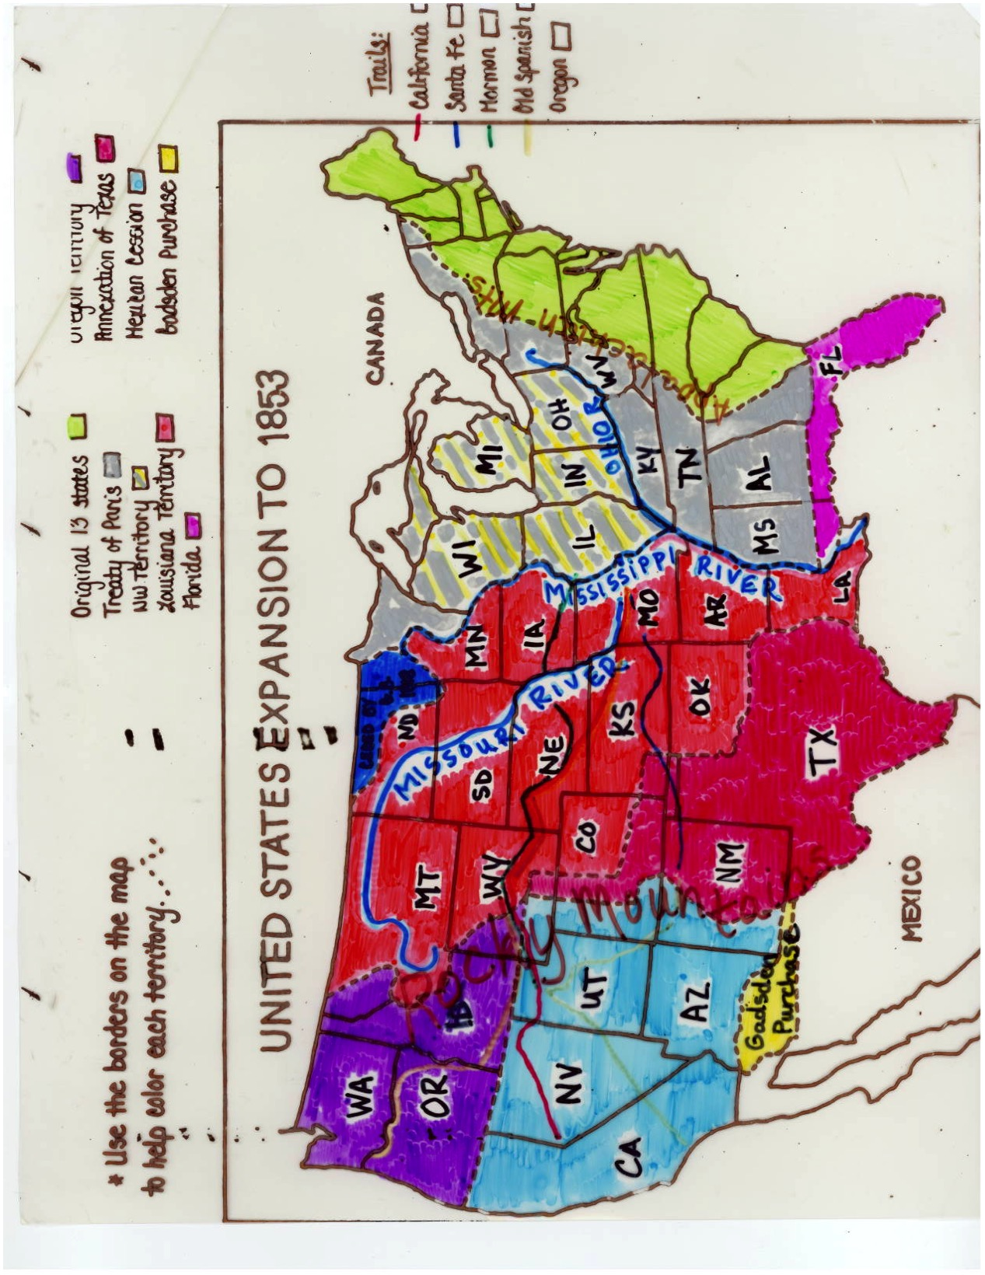

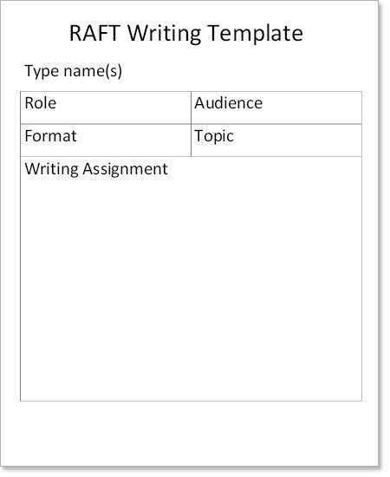

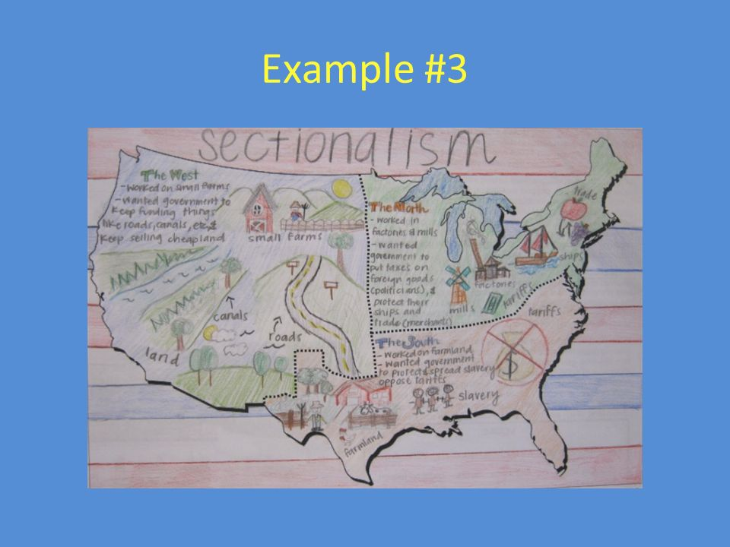

Manifest Destiny

Study Guide

**Things to Know**

**Vocab**

annex

cede

empresario

Forty-niners

Manifest Destiny

Prospect

Treaty of Guadelupe Hidalgo

Donner Party

missionaries

joint occupation

Lone Star Republic

Bear Flag Republic

Adams-Onis Treaty

expansionist

prairie schooner

warhawks

**What happened at:**

San Jacinto

Manifest Destiny

Alamo

Goliad

**Who were:**

James K. Polk (What was his campaign slogan?)

Santa Anna

Davy Crockett

Jim Bowie

William B Travis

John Jacob Astor

Narcissa and Marchus Whitman

Sam Houston

Donner Party

Stephen F Austin

John Sutter

James Marshall

Levi Strauss

**Where were:**

Rio Grande

California Trail

Rocky Mountains

Louisiana Purchase

Mississippi River

New Orleans

St. Louis

Nueces River

**Questions to answer**

Which president told Congress to expand aggressively in the West?

Who was the Mexican General who defeated the Texans at the Battle of the Alamo?

What were the terms of the Treaty of Guadalupe Hidalgo?

What group of immigrants faced additional hardships such as high monthly taxes, violent attacks, and discrimination in courts during the California Gold Rush.

From 1818 to 1846, Oregon was occupied jointly by what 2 countries?

Why did the Mexican government encourage settlement in Texas?

Who led Americans into Texas in 1822?

Who were some of the leaders at the Alamo?

How many Texans fought at the Alamo?

Which did Oregon have to offer the settlers?

Why was the forty-ninth parallel important in Oregon?

According to your notes, how long did it take to get to Oregon following the Oregon Trail?

What requirements did Mexico make of American citizens settling in Texas?

Who was the first president of the “Lone Star Republic?”

Why did the United States want the Gadsden Purchase?

Which river did Texas choose as its southern boundary upon entrance to the union?

Why did Americans want to go West? (list 3)

Describe 3 challenges or risks that settlers faced as they traveled West.

On whose land was gold first discovered in California near Sacramento? Who discovered the gold?

What time of the year was it best to head West?

Name ________________

Manifest Destiny

Chapter 15 Test

**Matching:**

**Write the letter that best corresponds with the following people, places, or things**

_____1. annex A. a group of travelers who were stranded in the Sierra Nevada mountains and resorted to cannibalism

_____2. cede B. third battle in Texas’ fight for independence, Santa Anna captured

_____3. Alamo C. to add

_____4. Forty-niners D. a devastating battle that inspired Texans to fight passionately for independence

_____5. San Jacinto E. gold seeker who moved to California during the gold rush

_____6. Manifest Destiny F. to search for gold

_____7. prospect G. ended the Mexican-American War and gave the US much of Mexico’s northern territory

_____8. Treaty of Guadalupe Hidalgo H. to give up

_____9. Donner Party I. people committed to spread religion to other people

_____10. missionaries J. belief that the US should span from the Atlantic to the Pacific

**Multiple Choice:**

**Choose the best possible answer, write it in the blank and circle it.**

_____11. Which president told Congress to expand aggressively in the West?

A.) Andrew Jackson B.) Martin Van Buren

C.) Sam Houston D.) James K. Polk

_____12. From 1818 to 1846, Oregon was occupied jointly by the United States and

A.) Texas B.) Great Britain C.) Spain D.) Russia

_____13. In 1822, Americans known as The Old Three Hundred were led into Texas by this empresario, _______.

A.) Davy Crockett B.) James Polk C.) Stephen F. Austin D.) Sam Houston

_____14. Why did the Mexican government encourage settlement in Texas?

A.) Protect border from Santa Anna B.) Raise money to pay war debts

C.) To search for gold D.) To build a trading post

_____15. This was the Mexican General who defeated the Texans at the Battle of the Alamo.

A.) Vincente Fox B.) Stephen F. Austin

C.) Miguel Hidalgo D.) Antonio Lopez de Santa Anna

_____16. Of the following which man did not fight at the Alamo?

A.) Davy Crockett B.) William B. Travis C.) Jim Bowie D.) James K. Polk

_____17. Approximately how many Texans fought at the Alamo?

A.) 30,000 B.) 189 C.)4000 D.) 189,000

_____18. Which president was responsible for ordering Zachary Taylor to cross the Nueces River, essentially beginning the start of the Mexican-American War?

A.) Andrew Jackson B.) Martin Van Buren

C.) Sam Houston D.) James K. Polk

_____19. The Treaty of Guadalupe Hidalgo set the boundary between

A.) the US and Canada B.) Canada and Oregon

C.) Canada and Mexico D.) Texas and Mexico

_____20. The lure of gold in California attracted miners from around the world. This group of immigrants faced additional hardships such as high monthly taxes, violent attacks, and discrimination in courts.

A.) Swiss B.) Chinese C.) Irish D.) Russian

**Short Answer:**

_____________________21. Why did the United States want the Gadsden Purchase?

_____________________23-25. Why did Americans want to go West? (list 3)

_____________________

_____________________

_____________________26. Which river did Texas choose as its southern boundary upon entrance to the union? _____________________27. On whose land was gold first discovered in California near Sacramento? _____________________28. Who discovered the gold? _____________________29. Levi Strauss made and sold what?

_____________________30. Who was the first president of the “Lone Star

Republic?”

_____________________31. What time of the year was it best to head West?

**Essay:**

**Please answer the following in complete sentences.**

32. Moving west was very challenging for early settlers. They faced many dangers along the way yet many still wanted to move west. Why?

33. How did James K. Polk’s belief in manifest destiny change America?

**Labeling:**  Identify the locations found on the map below. (I will write the numbers out on the map. Could not figure out how to do it on my computer..)



**34.** (river)_______________________ **39.** (city)_________________________

**35.** (trail)________________________ **40.** (river)_____________________

**36.** (mountains)__________________ **41.** (territory)______________________

**37.** (purchase)___________________ **42.** (city where the Missouri R meets the Mississippi R )

**38.** (river)_______________________ ________________________