Middle East After the First World War

Adam Chaussee
HIS 480 Historiography
April 24, 2017

Table of Contents
Part 1: Introduction
Geography………………………………………………………………………………...…Page 3
Background………………………………………………………………………………….Page 4
Culture……………………………………………………………………………………….Page 4
The Ottomans in the Great War……………………………………………...……………...Page 6

Part 2: Physical Impact
Early Discussions……………………………………………………………………………Page 8
Post War Agreement……………………………………………………………………….Page 11
Lines in the Sand…………………………………………………………………………...Page 13

Part 3: Social Impact
French Mandate………………………………………………………………………….... Page 14
British Mandate…………………………………………………………………………… Page 15

Part 4: Psychological Impact
Rise of Terrorism in the Middle East………………………………………………………Page 17

Part 5: Conclusion
Concluding Paragraph……………...………………………………………………………Page 18

Part 6: Extras
Sykes Picot Agreement…………………………………………………………………….Page 20
Sevres Treaty……………………………………………………………………………….Page 20
Lausanne Treaty……………………………………………………………………...…….Page 21
Bibliography………………………………………………………………………………..Page 22

Part I - Introduction:
The Middle East is known today as a region of never-ending conflict between political and religious groups fighting over the resources and holy lands that are limited in the land that was once the Ottoman Empire. This all started on June 28th, 1919 when the Treaty of Versailles was signed to put an end to the First World War and continued on, treaty after treaty devastating the people who lived in the area. William Spencer, in his book The Islamic States in Conflict, says it perfectly when he says, “The division of the Ottoman Provinces into territories controlled by European nations was the single most important factor in the development of the Islamic conflict in the Middle East in the 20th century.” This paper will argue this point by saying that the First World War has had and continues to have an enormous impact on the Middle East because of the way it has shaped and changed the region and its cultures physically, socially, and psychologically.
Geography
This paper will reference the region of the Middle East on a regular basis. This region can be defined in many different ways depending on who is talking about it and what they are using as their boundaries. Daniel Bates and Amal Rassam define the area, in which this paper will be talking about, in their book titled, Peoples and Cultures of the Middle East. They call this region the Central Middle East and it ranges from Turkey in the North, Iran in the East, Yemen and the Red Sea in the South, and as far West as Egypt and the Mediterranean Sea. This area includes the countries of Egypt, Israel, Jordan, Syria, Lebanon, Turkey, Iraq, Iran, Kuwait, United Arab Emirates, Oman, Yemen, Saudi Arabia, Qatar, and Bahrain. Many of the hot zones in which the news covers today are located in these countries. Geography is incredibly important to this region because of the scarcity of the natural resources, and the location of certain things such as religious centers and oil have been key factors in shaping the culture of the region.
Background
This region is one of the most culturally diverse areas in the entire world. It is often referred as the cradle of civilization because it was the area in which civilization began in the Fertile Crescent, and also those that rose up in Egypt. This is also the birthplace of the three major monotheistic religions. Judaism, Christianity, and Islam, were all formed and based out of this part of the world. Although Islam has been the dominant religion in since the Ottoman Empire took over around the turn of the fourteenth century. With so much diversity, and a lack of natural resources, there is a very good chance that there may be some conflict.
Culture
To take a greater look into the culture that thrived at the height of the Ottoman Empire, I look at the writings of T. E. Lawrence and his book titled, Seven Pillars of Wisdom. This was written while Lawrence was traveling the region as an archeologist before the war, and as a member of the British military during the war. Lawrence wanted to focus on seven major cities in the Middle East until the Arab revolt broke out against the Ottoman’s in 1916. After this event he shifted the course of the book to follow the revolt. The book itself provides fabulous detail about the culture of the Middle East when it was still under the rule of the Ottomans.
One of the keys to Lawrence’s writings is that he refers to the people based on where they live and or what they do. He does not use the names of countries, or different nationalities, because these things did not exist yet in the region. He uses phrases like, “The people of the desert” and “The people of the hills”. Bates and Rassam talk about this in their book as well. They say that, “Because ethnic categories are culturally defined, they can be manipulated and changed. In one situation, for example, an individual might identify him or herself as a Kurd, while another as a Turk or a Persian or an Arab…” Colbert Held and John Cummings add to this different way of identifying ones self by saying, “It is the cultural differentiation among peoples – variations in language, religion, customs and dress, values, and historical experiences – that creates separate group identities and nations.” They continue later on saying, “Two salient points about the patterns of peoples are worth noting at the outset: about half of the population of the region is non-Arab, and within its essential theological unity, Islam carries ethnic and political imprints and has several sectarian variations. Thus, the region has great cultural diversity.” There is so much diversity in this part of the world, they speak six major languages, believe in the three major monotheistic religions, and are divided into four major ethnic groups. This shows that the cultural identity of a person in this region is individualized, because there is so much diversity, and there is not a nationalistic mindset with the people of this area.
Much more emphasis is put on the family and the small villages or tribes in which they come from and live. Bates and Rassam say that, ”The family was and remains the basic unit of social organization in the Middle East.” Later on they describe this family structure in the region they quote Al-Nouri in saying, ”Two married brothers, for example, may reside with their wives and children in the same house along with their aged parents, pooling together resources to keep up with spiraling costs. One brother may be a poorly paid government employee while the other has an independent job…” This structure is very common throughout the Middle East, and is seen in both the rural and urban areas.
Another cultural aspect that is prominent in this area is nomadism. This region is primarily desert which makes it difficult to track down the resources that are necessary for living, unless you are talking about the areas around the coasts or inside of the fertile crescent, the area which lies between the Tigris and Euphrates Rivers. This means that many of the people who live in the central portions of the region have to be nomadic people who rely on moving from area to area searching for resources available to live off of. This way of living is ideal to survive in the harsh desert of the Arabian Peninsula. Lawrence notices this as well and writes, “So we see clans, born in the highlands of Yemen, thrust by stronger clans into the desert, where, unwillingly, they became nomad to keep themselves alive. We see them wandering, every year moving a little further north or a little further east as chance has sent them down one or other for he well-roads of the wilderness, till finally this pressure drives them from the desert again into the sown, with the like unwillingness of their first shrinking experiment in nomad life.”
All of these different cultural characteristics were affected with the influence of the European powers after the First World War. Families and cultures were torn apart when they came in and drew lines in the sand in attempt to change what has been working for thousands of years on its own.
The Ottomans in the Great War
The Ottoman Empire was interested in the war from the beginning, and were less excited about joining Germany, than they were about declaring Jihad on the French and the British who had been interfering with the Ottoman controlled Greeks on their way to attempting to acquire more and more colonies. The Ottomans allied with the Germans in the early 1900s, and greatly admired their military efficiency and wanted to mimic that. This did not go as planned however, Spencer writes about this and says this about the Ottoman sultan, “His call fell on deaf ears. Iran… had had its own troubles with European countries, and in any case the last thing the Iranians’ minds was to take up arms for the hated Ottoman sultan. Worse yet, a number of the sultan’s Arab subjects were persuaded by British agents to revolt against him, with the expectation that Britain would help them establish a state of their own after the war.” One of these British agents was of course none other that T.E. Lawrence who we have already discussed and will hear much more about later on. Another source, Iltur Turan, published his work in a journal called the Turkish Policy Quarterly, in which he talked about the Ottoman’s influence in the Great War, from a Turkish man’s perspective. He said, “The Ottoman Empire entered the War with the hope of recovering lost territories. The presence of Ottoman armies in Galicia (Ukraine) and Palestine during the war, only a couple of years after the Balkan Wars in which Bulgarian and Greek forces threatened to wrest away much of what remained in European Turkey, can only be explained by a grandiose dream. The dream was that with powerful allies, some of the lost territories of the Empire could be recovered, and its status as one of the major actors of European politics could be restored.”
Part 2: Physical Impact
Early Discussions
Even though the Ottoman’s were allies with Germany, they did not contribute to the cause of the war a whole lot because of the issues they had going on in their own land. Despite this, the British and French made them pay dearly at the conclusion of the war. In fact, the two nations were talking about what they were going to do with the land as early as 1916, far before the war was in hand; in fact it was even before the Americans had joined.
At this time, T.E. Lawrence was serving as a colonel in the British military, and had been in discussions with different Arab political leaders trying to convince them to Revolt against the Ottoman’s and help destroy the empire from the inside. Lawrence writes this about the beginning stages of the rebellion, “Some Englishmen… believed that a rebellion of Arabs against Turks would Enable England, while fighting Germany, simultaneously to defeat her ally Turkey. Their knowledge of the nature and power and country of the Arabic-speaking peoples made them think that the issue of such a rebellion would be happy: and indicated its character and method. So they allowed it to begin, having obtained formal assurances of help for it from the British Government.” This however did not go over well with everybody in the region. Lawrence continues saying, “It aroused mixed feelings and made strong friends and enemies, amid whose clashing jealousies its affairs began to miscarry.”
The beginning of this revolt to aid in the defeat of the Ottoman Empire greatly assisted both the British and the French during and after the war. And it was Lawrence, along with many others, who was to talk to these Arab leaders and aid in their efforts against the Ottoman’s. Lawrence knew that the revolt was not going as planned and decided to take it into his own hands. He said, “I had believed these misfortunes of the Revolt to be due to faulty leadership, or rather to the lack of leadership, Arab and English. So I went down to Arabia to see and consider its great men.” Lawrence did a lot with these Arabic leaders and had many discussions and talked of many promises including the largest which was an independent Arab state at the conclusion of the war. These discussions were quickly shattered after the war and the Arab people have been upset with the British and French ever since.
If this wasn’t enough lying by the Europeans for you, you are in luck. Enter the Balfour Declaration. This was a letter sent from James Balfour to Walter Rothschild who was a leader of the British Jewish community. The letter read, “His Majesty's government view with favour the establishment in Palestine of a national home for the Jewish people, and will use their best endeavours to facilitate the achievement of this object, it being clearly understood that nothing shall be done which may prejudice the civil and religious rights of existing non-Jewish communities in Palestine, or the rights and political status enjoyed by Jews in any other country” Sound familiar? If you recall, earlier on in this paper it talked about a similar promise that the British and T.E. Lawrence made to the Arabic people. Segev says, that the Balfour Declaration “was the product of neither military nor diplomatic interests but of prejudice, faith, and sleight of hand. The men who sired it were Christian and Zionist and, in many cases, anti-Semitic. They believed the Jews controlled the world.” The Palestine Royal Commission Report from July 1937 states what everybody now sees, and the beginning of the issues that happens so frequently in this area. It states, “Under the stress of the World War the British Government made promises to Arabs and Jews in order to obtain their support. On the strength of those promises both parties formed certain expectations.”
This letter that was used to gain the aid of the Jewish people in a fight against the Ottoman Empire during the First World War, can be directly linked to the chaos that lingers continuously over the country of Israel or the land that the Arabic people call Palestine.
A secret conversation between British diplomat Mark Sykes, and Frenchman Francois Georges-Picot began these discussions of going back on their promises as early as 1916, as Lawrence was still deeply involved with discussions and making promises to them. The agreement had many different clauses in which the land was to be divided up between the two countries in the result of an ally victory. The first clause reads as follows, “That France and Great Britain are prepared to recognize and protect an independent Arab State or a Confederation of Arab States in the areas (A) and (B) marked on the annexed map, under the suzerainty of an Arab chief. That in area (A) France, and in area (B) Great Britain, shall have priority of right of enterprise and local loans. That in area (A) France, and in area (B) Great Britain, shall alone supply advisers or foreign functionaries at the request of the Arab State or Confederation of Arab States.” There are eleven more terms that the British and French had agreed to, involving different portions of the region. Included on page 20, is a map of the region and how it would be divided.
This agreement was never actually signed into action and the agreement that was met at the end of the war was completely different than this, but it goes to show the mindset of the British and French early on in the war as they were looking at the region as a prize. In a book edited by Karl Yambert, Aurthur Goldschmidt Jr and Lawrence Davidson wrote about this agreement. They said, “Arab apologists claim that Amir Husayn knew nothing about the Sykes-Picot Agreement until after World War I. T. E. Lawrence was wracked by guilt because he had encouraged the Arabs on Britain’s behalf, thinking that they would get their independence after the war, when in fact they were being manipulated by British diplomacy.” They continue by saying that the statement is not true. They say, “Amir Husayn did know about the Sykes-Picot Agreement. Not only had the Allied secret been published by the communists after they seized control of Russia in 1917, but Husayn learned about the agreement from Turkish agents trying to draw him out of the war, and indeed, from the British and French themselves.” Husayn was promised by the British that the land that would be under his rule would be left unchanged so he continued his revolt and kept this agreement a secret from the rest of the Arab world. Lawrence would write in his book that, “Arabs could be swung on an idea as on a cord, for the unpledged allegiance of their minds made them obedient servants.”
Post-War Agreement
During the war, President Woodrow Wilson proposed his fourteen points. With these points he wanted to build peace after the war had ended. Goldschmidt and Davidson say, “He denounced secret treaties, urged self-determination for all peoples (specifically those who had been under Ottoman rule), and proposed creating a League of Nations to avert future wars. This in sense but an end to what was going to be the Sykes-Picot Agreement.
The document that actually put an end to the Great War was of course the Treaty of Versailles, but the less known Treaty of Sevres is what the Ottomans signed at the end of the war. This was the turning point in the shape of the Middle East, and their feelings toward the Western World. It was signed on August 10, 1920 and broke up the Ottoman Empire and distributed different portions of this land to different people who were to form new independent nations. These nations would then be put under strict mandate systems, giving some areas to the French and some to the British.
The Treaty gives the line-drawing duties to the Boundary Commission. It was their job to designate where each new country was going to begin and where it would end and so forth. This is very difficult to follow because of the wording, for example when talking about the boundaries of Syria they write, “From a point to be chosen on the eastern bank of the outlet of the Hassan Dede, about 3 kilometres north-west of Karatash Bu- run, north-eastwards to a point to be chosen on the Djaihun Irmak about 1 kilometre north of Babeli, a line to be fixed on the ground passing north of Karatash; thence to Kesik Kale, the course of the Djaihun Irmak upstream; thence north-eastwards to a point to be chosen on the Djaihun Irmak about 15 kilometres east-southeast of Karsbazar, a line to be fixed on the ground passing north of Kara Tepe; thence to the bend in the Djaihun Irmak situated west of Duldul Dagh, the course of the Djaihun Irmak upstream; thence in a general south-easterly direction to a point to be chosen on Emir Musi Dagh about 15 kilometres south-south-west of Giaour Geul a line to be fixed on the ground at a distance of about 18 kilometres from the railway, and leaving Duldul Dagh to Syria.” Everyone who reads it can interpret this differently, and it is one of the major issues in that part of the world. One nation thinks that a certain section of land is theirs where another will claim that the actually own it. This is what leads to war and constant conflict. Included on page 20 is a map of the region under the Sevres Treaty.
Because of all of the miscommunications that the Treaty of Sevres started, it failed miserably and nobody involved knew which country owned what. On top of that the Greeks and Soviets were attempting to move in on different parts of Turkey and gain control of those areas, specifically Armenia. This feud lasted a few years until everybody who was involved in the original signing of Sevres, except for Greece, got back together again and discussed what would be later known as the Treaty of Lausanne. A map of the region under this treaty is also included on page 21.
Lines in the Sand
The Treaty of Lausanne was signed on July 24, 1923, just a few short years after the signing of the Treaty of Sevres. The first twenty-two articles of this Treaty were set aside to break up what was left of the Ottoman Empire after the war. Turkey had been leading the discussions with the European powers and were the most upset with what had happened with the Treaty of Sevres (See Map). In the Treaty of Lausanne, Turkey would gain much more land, but give control over the rest of the Middle East to the French and British in which they would do with it what they please (See Map).
With all of their new control over these Middle Eastern people, the French and British, along with the ideas of United States President, Woodrow Wilson, decided that they would institute different mandates on the areas in which they were going to be in control over. Wilson’s idea was that these nations who had been under the rule of the Ottoman’s for so long, would be paired up with a “Great Power”, that the League of Nations would call mandatory, from whom they would learn how to govern themselves. Each mandatory would have to report back to the Permanent Mandates Commission, which was a body of the League of Nations, so that they were not able to exploit the new nation. The Mandate of Syria and what would eventually be Lebanon would be given to France, and the British would receive the mandates of Iraq, Palestine, and the land that is now Jordan. At this point, the Arabs realized that their dream of an independent Arab state was crushed.
Part 3: Social Impact
French Mandate:
The French ruled Syria as if it were a colony, absolutely crushing any idea of a Syrian Nationalist movement. They even went as far as to separate the region hoping to weaken the nationalists that were in the area. They separated what is now Lebanon, and because it had a Christian Majority, unlike the rest of the area, it actually worked out and was about the only thing that the French got right as long as they were there. All of the other divisions of Syria soon ended after they were put into place. Despite that, the Syrians rebelled often against French rule, hoping to push them out and become independent. William Spencer writes, “The French set up Syria and Lebanon as French-style republics with French laws, French schools and universities, and an elected president and legislature. But real power was in the hands of the French high commissioner, backed by the French army and police.”
In an article, written by Ayse Tekdal Fildis, a professor of Political Sciences at Halic University in Istanbul, titled “The Troubles in Syria: Spawned by French Divide and Rule” she writes about the French mandate of Syria and how the impact of if the French impacted the people who lived there. She says, “Great Britain and France transformed what had been relatively quiet provinces of the Ottoman Empire into some of the least stable and internationally explosive states in the world.” she continues on by saying, “Minority Consciousness, reinforced by a combination of geography, religious differences, communal segregation and regional separatism, had a damaging impact on Syrian political life even long after the mandate.” The French mishandled the mandate system and Syria has still not recovered from what happened. They failed to give Syria what they needed to become a successful self-governing nation, which was the only reason they were there in the first place. Fildis states that, “France was there for her own strategic, economic and ideological purposes. The French made very few attempts to promote or expedite the formal independence of either Syria or Lebanon.”
British Mandate:
The French were not the only one who mishandled the mandate system in the Middle East. In fact, what the British did in the areas of Iraq and Palestine may have been even worse. Before the British mandated the area of what was then Palestine it was a relatively peaceful place. Tom Segev wrote the book, One Palestine, Complete, and gives some extremely good insight into what happened in the area under British rule. He writes, “Palestine was a rather remote region of the Ottoman Empire with no central government of its own and few accepted norms. Life proceeded slowly at a pace by the stride of the camel and the reins of tradition.” Segev continues this thought later on saying, “Muslims, Jews or Christians, a powerful religious and emotional force drew them to the land of Israel. Some stayed only a short time, while others settled permanently. Together they created a magical brew of prophecy and illusion, entrepreneurship, pioneerism, and adventurism – a multicultural revolution that lasted a hundred years.”
Things were going very well up until the end of the War when Britain went back on their promise that they made in the Balfour Declaration and mandated this region as a result of the Treaty of Lausanne. The mindset of the people changed rapidly. What used to work as a mostly peaceful land that was sacred to three different religions turned into a total warzone, in which there were Arabs fighting the British, Jews fighting the British, and Jews fighting Arabs. We see this in writing again in the PRC Report of July 1937. They write, “An irrepressible conflict has arisen between two national communities within the narrow bounds of one small country. About 1,000,000 Arabs are in strife, open or latent, with some 400,000 Jews. There is no common ground between them.” They continue on later saying that, “Arabs and Jews might possibly learn to live and work together in Palestine if they would make a genuine effort to reconcile and combine their national ideals and so build up in time a joint or dual nationality. But this they cannot do. The War and its sequel have inspired all Arabs with the hope of reviving in a free and united Arab world the traditions of the Arab golden age.”
Things are not good in Palestine to say the least, but this is not the only place that the British are mandating at this point. For as poorly as the mandate of Palestine went for the British, the Iraqi mandate went surprisingly well for the most part. There were some hiccups along the way but the British managed to choose the right man for power in Faysal. He was a strong leader and was put into power by a rigged plebiscite or vote, but despite that he was able to take one of the poorest regions of the Ottoman Empire and be the first nation to “graduate” from their mandate status in 1932. But the reoccurring theme of these decisions that the British were making is of course, for every good thing that they do they come right back with a bad reason for doing it. James DeFronzo, in Yambert’s book says, “Britain did not establish a truly democratic political system in Iraq when it had the opportunity after World War I. Its leaders drew Iraq’s borders with the apparent intent of maintaining British control over Mesopotamia’s oil.” This opened the door to what would eventually happen between the US and the Iraqis.
Overall these mandate systems changed the way the people in these countries thought and their cultures as a whole. The French and British forced these people into impossible situations in which they had no choice but to fail. This was the start of the Western World forcing their beliefs on these people for their personal gain and it would not be the end. We see this hatred from these people toward the west still today with ISIS gaining power and also with terrorist organizations such as Al-Qaida.
Part 4: Psychological Impact
Rise of Terrorism in the Middle East
Perhaps the most important and longest lasting effect of the European powers in the Middle East after WWI was the psychological impact that it had on the people who lived there, and the ideologies of the people who were in power. We see this largely in the hatred towards the Western World today because they continue to try and influence this region. It started with the French and the British, but after these nations had been there long enough of course the United States had to poke their head into the situation and get involved. After that happened there was no stopping what was coming.
Osama bin Laden is perhaps the most well known person from the region who has expressed his hatred toward the western world, specifically America. He was the leader of the terrorist organization Al-Qaida before he was captured and eventually killed by the US. But this point, he had already stated his message and it spread fast. His Declaration of Jihad against Americans is only one of many examples of this hatred. In this speech he says, “I say to our Muslim brothers across the world: your brothers in Saudi Arabia and Palestine are calling for your help and asking you to share with them in the jihad against the enemies of God, your enemies the Israelis and Americans.” Bin Laden calls for all of his Arab brothers to stand up to the Western world and force them out of their homeland, the land that had been promised to them. He calls for everybody to “Boycott all American goods,” and to come together “in order to liberate the holy places of Islam…” Al-Qaida is not the only group that has been waging war on the Western World as of late. ISIS has come together in hope of creating an Islamic state in the Middle East and has been causing a lot of stress on the world.
Part 5: Conclusion
Throughout the modern history of the Middle East, there has continued to be conflict in areas such as Israel between the Jewish people the Arabs who were there before them, there have been promises made to these people that have been broken, and there continues to be a general hatred towards the western world that emanates from this part of the world. This paper was written to answer the previously stated question of, what impact did the First World War have on the Middle East? This paper argued that the First World War has had and continues to have an enormous impact on the Middle East because of the way it has shaped and changed the region and its cultures physically, socially, and psychologically.

Maps:
Sykes-Picot Agreement
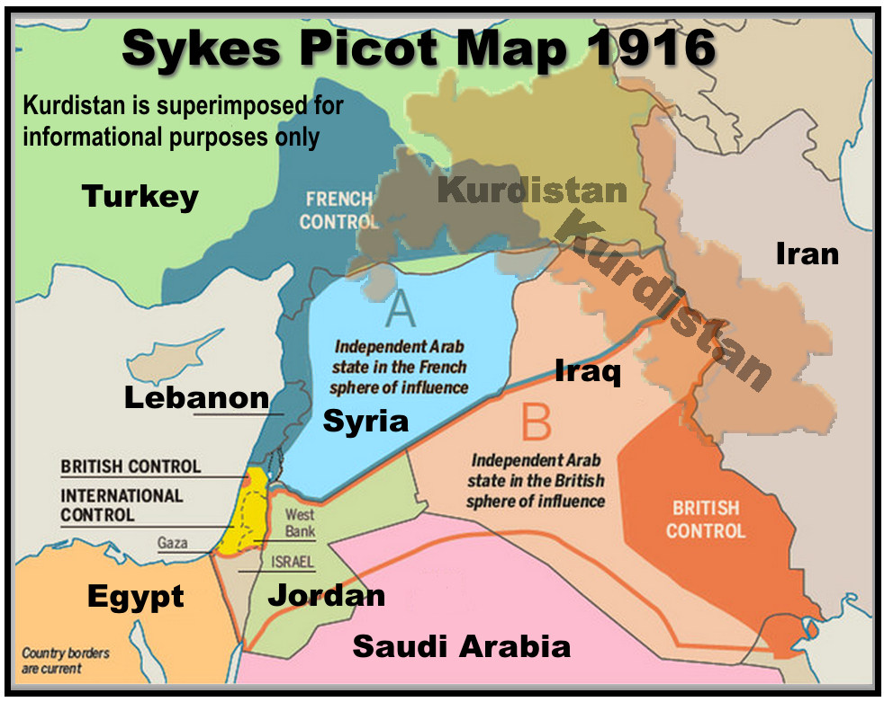

Sevres Treaty
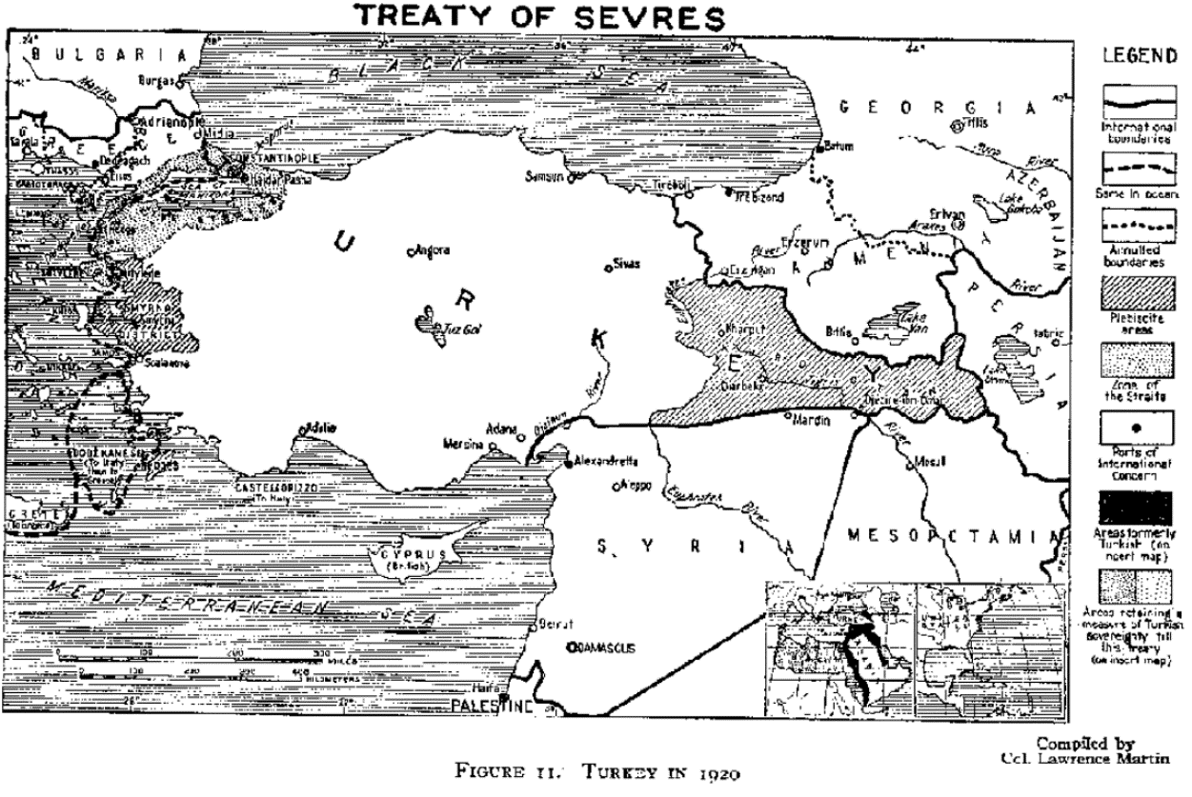

Treaty of Lausanne
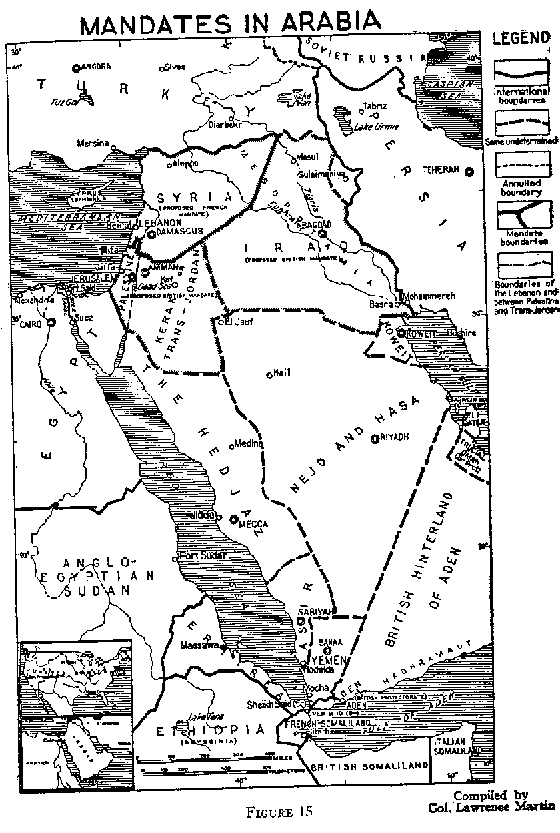

Bibliography

- Bates, Daniel G., and Amal Rassam. Peoples and cultures of the Middle East. Upper Saddle River, NJ: Prentice Hall, 2001. Book 1.

- Cleveland, William L. A History of the Modern Middle East. Boulder, CO: Westview Press. 2004. Book 2.

- Columnist, CM Guest. "Time for a new Sykes-Picot Agreement to fix the Middle East." Cyprus Mail. November 01, 2016. Accessed March 23, 2017. http://cyprus- mail.com/2016/03/08/time-for-a-new-sykes-picot-agreement-to-fix-the-middle-east/. Map 1.

- Fildis, Ayse Tekdal. 2011. "The Troubles in Syria: Spawned by French Divide and Rule." Middle East Policy 18, no. 4: 129-139. Academic Search Premier, EBSCOhost (accessed March 22, 2017). Journal 1.

- "Lausanne Treaty: Part I." HR-Net - Hellenic Resources Network. Accessed March 23, 2017. http://www.hri.org/docs/lausanne/part1.html. Primary source 1.

- Lawrence, T. E. Seven Pillars of Wisdom. Garden City, New York: Garden City Publishing Co., 1926. Book 3.

- Milestone Documents. "Osama bin Laden: Declaration of Jihad against Americans." Accessed February 27, 2017. https://www.milestonedocuments.com/documents/view/osama-bin-ladens-declaration-of- jihad-against-americans/text. Primary source 2.

- Milestone Documents. "The Palestine Mandate." Accessed February 27, 2017. https://www.milestonedocuments.com/documents/view/the-palestine-mandate/text. Primary source 3.

- "Pages 370-372 from Palestine Royal Commission Report - July 1937 Cmd 5479.pdf." Google Docs. Accessed March 23, 2017. https://docs.google.com/file/d/0B-5- JeCa2Z7hMTh3UDZUSm43OU0/edit. Primary Source 4.

- Podler, Guy. “A South Korean Progressive Outlook on the Middle East Conflict:Contextualizing Hankyoreh’s Coverage of the Gaza War.” Korea Observer 44, no. 2 (2013): 223-247. MLA International Bibliography, EBSCOhost. Accessed February 27, 2017. Journal 2.

- Segev, Tom. One Palestine, complete: Jews and Arabs under the British Mandate. New York: Metropolitan Books, 2000. Book 4.

- Spencer, William. The Islamic States in Conflict. New York: Franklin Watts. 1983. Book 5.

- "Sevres Treaty: Part II." HR-Net - Hellenic Resources Network. Accessed March 23, 2017. http://www.hri.org/docs/sevres/part2.html. Primary Source 5.

- Turan, Ilter. “The First World War Hundred Years Later.” Turkish Policy Quarterly, Volume 13, no. 1 (Spring 2014): 67-77. Accessed February 2, 2017. Journal 3.

- World War I Document Archive. “Sykes-Picot Agreement.” Accessed February 27, 2017. https://www.saylor.org/site/wp-content/uploads/2011/08/HIST351-9.2.4-Sykes-Picot- Agreement.pdf. Primary Source 6.

- Yambert, Karl. The contemporary Middle East: a Westview reader. Boulder, CO: Westview Press, 2010. Book 6.

William Spencer, The Islamic States in Conflict. (New York: Franklin Watts, 1983) Pg 27
Daniel G. Bates and Amal Rassam, Peoples and cultures of the Middle East (Upper Saddle River, NJ: Prentice Hall, 2001) Pg xiii
T. E. Lawrence, Seven Pillars of Wisdom (Garden City, New York: Garden City Publishing Co., 1926)
Ibid., 36
Daniel G. Bates and Amal Rassam, Peoples and cultures of the Middle East (Upper Saddle River, NJ: Prentice Hall, 2001) 90
Karl Yambert, The contemporary Middle East: a Westview reader (Boulder, CO: Westview Press, 2010). Pg 14
Ibid., 24
Daniel G. Bates and Amal Rassam, Peoples and cultures of the Middle East (Upper Saddle River, NJ: Prentice Hall, 2001) 207
Daniel G. Bates and Amal Rassam, Peoples and cultures of the Middle East (Upper Saddle River, NJ: Prentice Hall, 2001) 209
T. E. Lawrence, Seven Pillars of Wisdom (Garden City, New York: Garden City Publishing Co., 1926) 37
12 William Spencer, The Islamic States in Conflict. (New York: Franklin Watts, 1983) Pg 26
Ilter Turan, “The First World War Hundred Years Later,” Turkish Policy Quarterly, Volume 13, no. 1 (Spring 2014): 67-77, Accessed February 2, 2017
T. E. Lawrence, Seven Pillars of Wisdom (Garden City, New York: Garden City Publishing Co., 1926) 7
Ibid., 7
Ibid., 8
Tom Segev, One Palestine, complete: Jews and Arabs under the British Mandate (New York: Metropolitan Books, 2000). Pg 33
"Pages 370-372 from Palestine Royal Commission Report - July 1937 Cmd 5479.pdf," Google Docs, , accessed March 23, 2017, https://docs.google.com/file/d/0B-5-JeCa2Z7hMTh3UDZUSm43OU0/edit.
World War I Document Archive, “Sykes-Picot Agreement,” Saylor, Accessed February 27, 2017. https://www.saylor.org/site/wp-content/uploads/2011/08/HIST351-9.2.4-Sykes-Picot-Agreement.pdf.
CM Guest Columnist, "Time for a new Sykes-Picot Agreement to fix the Middle East," Cyprus Mail, November 01, 2016, , accessed March 23, 2017, http://cyprus-mail.com/2016/03/08/time-for-a-new-sykes-picot-agreement-to-fix-the-middle-east/
Karl Yambert, The contemporary Middle East: a Westview reader (Boulder, CO: Westview Press, 2010). Pg 46
William Spencer, The Islamic States in Conflict. (New York: Franklin Watts, 1983) Pg 46
"Sevres Treaty: Part II," HR-Net - Hellenic Resources Network, , accessed March 23, 2017, http://www.hri.org/docs/sevres/part2.html.
Ibid.
William L. Cleveland, A history of the modern Middle East (Boulder, Colo: Westview Press, 2007). pg 177
Lausanne Treaty: Part I," HR-Net - Hellenic Resources Network, , accessed March 23, 2017, http://www.hri.org/docs/lausanne/part1.html.
Ibid.
Karl Yambert, The contemporary Middle East: a Westview reader (Boulder, CO: Westview Press, 2010). Pg 49
William Spencer, The Islamic States in Conflict. (New York: Franklin Watts, 1983) Pg 49
Ayse Tekdal Fildis, "The Troubles in Syria: Spawned by French Divide and Rule," Middle East Policy 18, no. 4: 129-139, Academic Search Premier, EBSCOhost (accessed March 22, 2017)
Ibid.
Tom Segev, One Palestine, complete: Jews and Arabs under the British Mandate (New York: Metropolitan Books, 2000). 1
Ibid., 2
"Pages 370-372 from Palestine Royal Commission Report - July 1937 Cmd 5479.pdf," Google Docs, , accessed March 23, 2017, https://docs.google.com/file/d/0B-5-JeCa2Z7hMTh3UDZUSm43OU0/edit.
Ibid.
Karl Yambert, The contemporary Middle East: a Westview reader (Boulder, CO: Westview Press, 2010). Pg 51
Ibid., 240
"Osama bin Laden: Declaration of Jihad against Americans," Milestone Documents, Accessed February 27, 2017. https://www.milestonedocuments.com/documents/view/osama-bin-ladens-declaration-of-jihad-against-americans/text.
Ibid.

